CURRICULAM VITAE
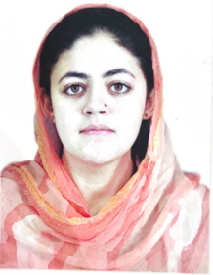

Name : SARA ISRAR
Father Name: MUHAMMAD ISRAR
Date of Birth: 12th Feb, 2000
Domicile : Tangi, District Charsadda
CNIC No : 17301-5442718-0
Nationality : Pakistani
Hobbies : Dress Designing, Event Management
House Address: House No 8 Street 11 Sector C/2 Phase, 5 Hayatabad, Peshawar
S.NO | Qualification | Year of Passing | Annual/Semester | Total Marks | Obtained Marks | %age | Name of the School, College, Board/  University
1 | SSC | 2015 | Annual | 1100 | 929 | 84.5% | Qurtaba School & College, Hayatabad.  (BISEP)
2 | FSC | 2017 | Annual | 1100 | 934 | 85% | Jinnah College for Women, university of Peshawar  (BISEP)
3 | BDS | 2022 | Annual | 3550 | 2053 | 57.8% | Peshawar Medical & Dental College,  (Riphah University, Islamabad)
Educational Record:

Experience
- One year House job in Peshawar Dental Hospital and got practical trainings on various aspects of dentistry.

- Worked as Volunteer/attachment in Hayatabad Medical Complex for two weeks in Hospital Emergency and got acquainted with emergency situation handling

- Demostator in sardar begum dental college from 5/5/2023 to 30/5/2025

- Demonstrator in Khyber medical university oral biology department from june 2025 still date

- Aesthetic physician done level 1 from PALD
References:
Will be provided on request

