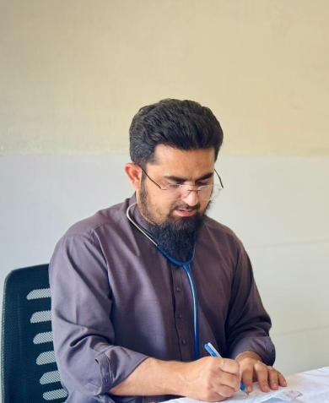
Dr. Muhammad ishaq
Personal Data
Nationality: | Pakistani
Domicile: | Peshawar, Khyber Pakhtunkhwa
Mobile Number: | 03411944386
Email Address: | drishaqktk@gmail.com  muhammadishaq.forensic@kmu.edu.pk

Academics
Degree | Session |  | Institution
DMJ | 2023-2025 |  | Khyber medical university Peshawar
MBBS | 2014-2020 |  | Khyber medical university Peshawar
Higher Secondary  School Certificate (Pre  Medical) | 2009-2011 | Grade A1 | Board of Intermediate and Secondary Education Peshawar, KPK, Pakistan.
Secondary School  Certificate (Science) | 2011-2013 | Grade A | Board of Intermediate and Secondary Education Peshawar, KPK, Pakistan.

Certificate Courses:
- Certificate in Health Professions Education (CHPE) from Institute of Health Professions Education, Khyber Medical University, Peshawar (Batch-82)
- CHR from institute of public health and social sciences, Khyber Medical University, Peshawar (Batch-50)

TEACHING EXPERIENCE

- Lecturer in department of forensic medicine and toxicology in FMDC ABBOTABAD (18th March 2021 - 8th august 2021)
- Lecturer in department of forensic medicine and toxicology in KMU IMS KOHAT (9th august 2021 -8th august 2024)
- Lecturer in department of forensic medicine and toxicology in PIMC PESHAWAR (3rd Sep 2024 – 29 MAY 2025)
- Lecturer in department of forensic medicine and toxicology in KMU IBMS PESHAWAR (30 MAY 2025 TILL DATE)
- Got assistant prof eligibility from PMDC

House job
March 2020 – march 2021 (MTI BANNU)

Publications

- Epidemiological and forensic assessment of firearm related death in Peshawar

2 Prevalence, demographic factors and seasonal variations of poisoning cases reported
To a forensic medicine department in Peshawar; a cross sectional study

:

