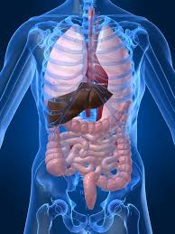

These presentations are based on a critical analysis of five articles with interpretation of the data by our students. Your presence and critique is highly anticipated to encourage our students to develop a mindset of critical analysis to help in further research.

Anatomy Department, IBMS

Phase 5, KMU

E-mail address: surghuma73@gmail.com

## 15th February 2016

10.00 am, IBMS, KMU

# Poster Presentation by

# MPhil Anatomy Students