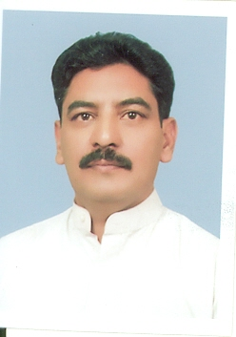
Dr. Shafiq Ahmad Tariq
Professor

Dr Shafiq Ahmad Tariq has joined Department of Pharmacology, Institute of Basic Medical Sciences (IBMS) Khyber Medical University Peshawar in January, 2011. Previously he worked as Pharmacist in Health Department of KPK and Pharmaceutical Chemist in Khyber Medical College, Peshawar. He got B-Pharm degree in 1988,M.Phil degree in 1993, and PhD in Pharmaceutical Sciences in 2009.
He discovered and added three new compounds (Indigoferin I, II and III) to the global database of Phytocompounds and enhanced knowledge on the Phytochemistry.
His area of research interest is
- Drug Development
- Phytochemistry
- Genomics
- Pharmacogenomics

He supervised 23 M.Phil scholars; currently 06 M.Phil and 04 PhD Scholars are under his supervision
Dr Shafiq Ahmad Tariq has published 28 research articles in national and international ISI indexed Journals. Moreover he is the member of different bodies of Khyber Medical University.
Contact Information:
Professor
Pharmacology
IBMS, Khyber Medical University
Hayatabad Phase- V Peshawar
Ph. # 092-9217838

