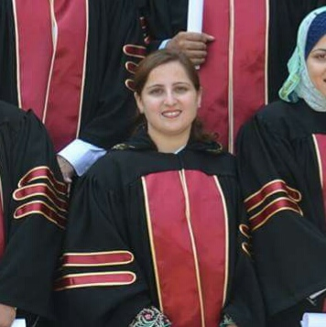
Dr Sadia Fatima
Assistant Professor
IBMS, Khyber Medical University, Pakistan
MBBS (Pakistan), PGD (UK), PhD (UK)

Dr Sadia Fatima has joined Department of Biochemistry, Institute of Basic medical sciences (IBMS) Khyber medical university Peshawar in April, 2015. Previously she worked as lecturer at Ayub Medical College, Abbottabad.
Dr Sadia Fatima had completed her PhD in human Nutrition from University of Glasgow, UK. She was supervised by Dr Dalia Malkova, Dr Konstantinos Gerasimidis and Prof Charlotte Wright. She had a medical background and her field of interest and thesis was in undernourished and malnourished children and young adults. Her research work has thus far focused on the level of energy intake compensation in lean adult women following HENSD consumption, and to find out how it relates to the response of a range of hormonal and metabolic appetite regulators as well as measure of gastric emptying. She has also investigated the time scale and level of energy intake compensation after five days of supplementation with HENSD in the afternoon and also investigated the impact of five days supplementation on plasma lipids and insulin sensitivity.
Her future interests are to investigate the impact of longer duration of supplementation or different degrees of supplementation with HENSD on lipoprotein, glucose and insulin metabolism in underweight pregnant females, healthy and obese subjects. She is also interested to investigate the possible side effects of energy rich; lipid based nutritional supplements such as RTUF and their long-term outcomes on malnourished children. Being one of the very few experts in the field of human nutrition and more specifically the child health and only female in the province, she wants to utilise her expertise for the full betterment of the society. She wants to establish a highly equipped Clinical Trial Room and probe into the malnutrition status, treatment, management and preventive strategies based on local data and research. Because the research conducted in the West may not fully applicable to the local circumstances of this part of the world.
Dr Sadia has 16 research publications to her credit in impact journals. She is currently supervising 10 M Phil and 1 PhD scholars.
Contact Details:
Assistant Professor IBMS,
Khyber Medical University
Hayatabad Phase 5, Peshawar
Mobile Number: 0331- 5812345
0321-5812345
Email: drsadiafatima@gmail.com

