PERSONAL PROFILE
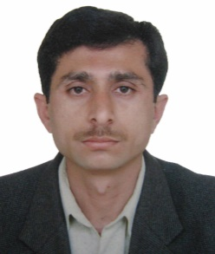
I am Roshan Ali, working in IBMS, KMU as Assistant Professor since June 1, 2011. I am an energetic, passionate, self motivated individual with a desire to learn, teach, share knowledge, discover and succeed in life. Always trying to motivate others towards high quality research is my hobby. In addition to Biochemistry and Molecular Biology, my other interests include learning and teaching Programing (R, Python3, Perl6, Ring, SQL, HTML etc), Bioinformatics (Drug discovery, Docking, Phylogenetics, Sequence analysis and Protein Structure function relationship etc), Physics (especially Quantum and modern Physics), Mathematics (especially patterns in Prime Numbers) and Computer Science (especially Progarmming Languages). One of the biggest quality I have is self-learning ability that’s why I always love to learn and teach new things. I cooperate with students and scholars from all the departments of KMU. I am in search of people who love science to the extent of madness. I would be very lucky if I find an environment full of science where everyone thinks, sees, touches, smells, speaks, and listens science. I believe in academic freedom, free of compulsions. The things I hate include waste of time and money on useless formalities, meetings, useless activities, things that bring no fruit to the university and to the humanity.
My PhD research identifies a CNMT gene for the first time in a basal angiosperm (Aristolochia fimbriata). We then analyzed the sequence, predicted its 3D structure, mechanism of its reaction as well as its evolutionary relationship with other angiosperms. Almost all of the PhD research work was carried out in the Pennsylvania State University, USA. Since then I have published several papers, most of which purely computational.
KEY SKILLS
Programming in R, Python3, LaTex and HTML etc.
Use of computational tools in research, Drug Discovery especially
Data analysis through R and other bioinformatics tools
EndNote, Mendeley, Zotero, BibTex and BibLaTex
ACADEMICS
PhD in 2011 from University of Peshawar (Research done in Penn State University, USA)
MSc in 2003 from Department of Chemistry, University of Peshawar
BSc in 2001 from University of Peshawar
BEd in 2004 from University of Peshawar
CHPE in 2013 from Khyber Medical University

