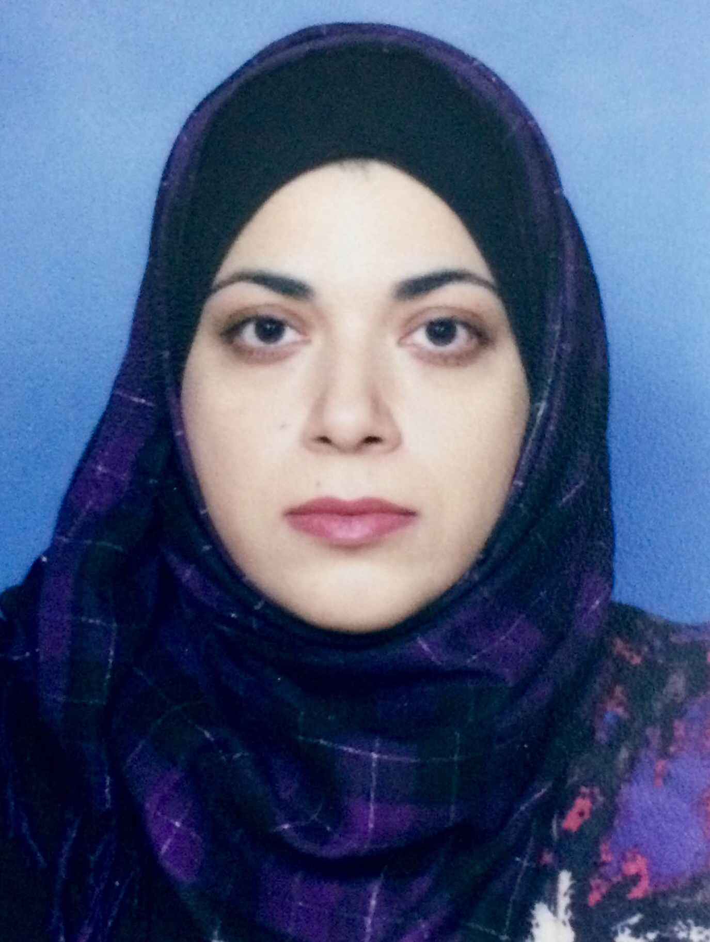
Dr Najma Baseer
MBBS (Pak), MHPE (Pak), PhD Neuroscience (UK),
Assistant Professor Anatomy
IBMS, Khyber Medical University
Peshawar, Pakistan.

Dr.Najma Baseer joined Anatomy department of IBMS, Khyber Medical University as an Assistant Professor in 2014. She is a distinction holder medic and has a PhD Neuroscience degree from University of Glasgow. Her PhD research project was based on "Spinal Cord neuronal circuitry involving dorsal horn projection cells". She investigated the neuronal circuitry of the spinal dorsal horn using immunocytochemistry combined with confocal and electron microscopy to identify excitatory and inhibitory synaptic contacts on dorsal horn projection cells involved in the pain and itch transmission. She has also supervised masters and bachelors students at university of Glasgow and worked there as a PBL facilitator and a graduate training assistant (GTA) for 3 years.

She has recently completed her Masters in Health Professions Education & Research with a distinction. Till date, she has 7 publications to her merit, which cover a wide range of topics from neuroanatomical sciences to medical education. She is currently a member of editorial boards of Khyber medical university journal (KMUJ) and Advances in Basic medical sciences (ABMS). She is also the secretary of Institutional Board of Studies (IBOS), IBMS, KMU and Higher Education Commission of Pakistan (HEC) recognized postgraduate supervisor.

She is currently working on a number of research projects with 10 MPhil & PhD students under her supervision. Her fields of expertise include Immunocytochemistry, Confocal Microscopy, Immunofluorescence Microscopy, scanning and transmitted Electron microscopy, Digital reconstruction using MBF Bioscience software, Under and postgraduate Curriculum development and implementation, Faculty development programs & training workshops.

Contact Information:
Assistant Professor
Institute of Basic Medical Sciences,
Khyber Medical University
Hayatabad Phase V
Peshawar, Pakistan
Email: drnajma.ibms@kmu.edu.pk

