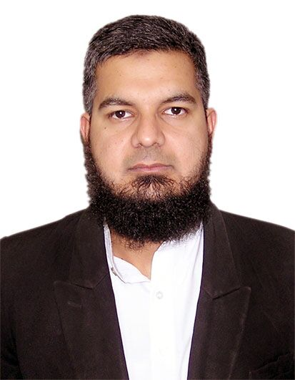
Dr. Muhammad Omar Malik
Assistant Professor, Physiology
IBMS, Khyber Medical University, Peshawar
MBBS (RMC-UHS), BSC (Punjab University), M.Phil. (NUST), PhD (Glasgow)

Dr Muhammad Omar Malik joined Department of Physiology, Institute of Basic medical
Sciences (IBMS), Khyber Medical University (KMU) Peshawar in June 2015 as Assistant Professor. Previously he worked as Assistant Professor at Wah Medical College, Wah Cantt. He has also worked as Assistant Professor and Head of Physiology Department in Nawaz Sharif Medical College Gujrat.
Dr Muhammad Omar Malik did his MBBS from Rawalpindi Medical College, Rawalpindi. He got his BSC from Punjab University and MPhil in Physiology from NUST, Islamabad. He got his PhD in Physiology from University of Glasgow, United Kingdom. He has done work in diabetic clinics in Stobhill Hospital and Royal Infirmary Glasgow under supervision of Prof John Petrie, Dr Robert Lindsay and Prof Naveed Sattar. He has worked in The Scottish Care Information – Diabetes (SCI- Diabetes) for four years. His main area of interest is diabetes and its management. He has also worked on insulin resistance, hypertension and cardiovascular risk factors relationship with cardiovascular disease. He has also established Diabetes Care and Research Centre in Khyber Medical University. He has developed treatment strategies for hormonal management for Diabetes and Obesity. He is also working on establishing Sports Medicine centre in KMU. He has 7 publications in high impact journals. 3 students have completed MPhil under his supervision. Currently he is supervising 9 MPhil and 4 PhD students.

Contact Information:
Dr. Muhammad Omar Malik
Assistant Professor
IBMS, Khyber Medical University
Hayatabad Phase 5
Peshawar
Email: omarmalik786@hotmail.com

