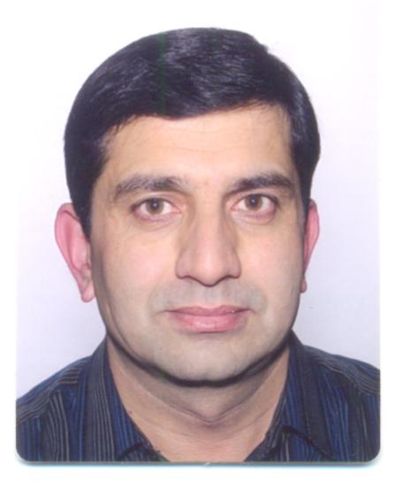
Dr Ihsan Ullah
Assistant Professor, Pathology (Microbiology)
IBMS, Khyber Medical University, Peshawar
MBBS (Pak) PGD EBM & HPE (Glasgow UK), PhD Pathology (Glasgow UK)

Dr Ihsan Ullah is serving the Institute of Basic Medical Sciences (IBMS) Khyber Medical University Peshawar since October 26, 2014.
Previously, he served Department of Health Khyber Pakhtunkhwa as Medical Officer and Registrar department of Medicine for five years 2002-2007. He joined department of Pathology, Khyber Girls Medical College Peshawar in 2007 and served as Lecturer Pathology till October 2014.
He did his MBBS degree from Ayub Medical College Abbottabad (Session 1995-1999). He did his Postgraduate diploma in Evidence Based Medicine and Health Professions Education from the University of Glasgow (Session 2010-2011). He did his PhD in Pathology under the supervision of Professor Thomas John Evans with Special focus on Immunology and innate immunity, from the University of Glasgow, Western Infirmary Hospital (Session 2011-2014).
His area of specialization is immunology, innate immunity with special research interest in host responses against pathogens. He is also interested in bacterial immunology, drug resistance, nosocomial infections and medical mycology. His teaching interests include bioethics, communication skills, personality development and academic writing.
Publication:
Impact Factor 16
A total of 15 Publications in (HEC/PMDC) recognized journals.

Contact Information:
Dr Ihsan Ullah
Assistant Professor
IBMS, Khyber Medical University
Phase 5, Hayatabad Peshawar, Pakistan
Phone: 00923139558883
Email: drihsan.ibms@kmu.edu.pk

