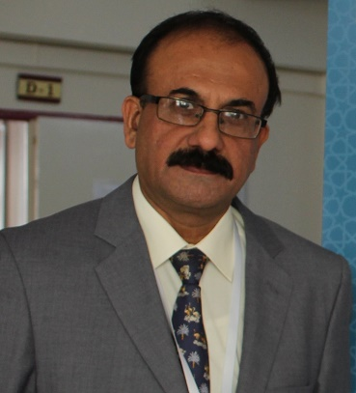

Dr. Tayyab ur Rehman
M.Sc. Zoology (Pak), PhD Molecular Genetics (London),
PG Diploma in Parasitology (London).

Assistant Professor (Tenured)
Department of Molecular Biology & Genetics
Institute of Basic Medical Sciences
Khyber Medical University, Peshawar.
Email: tayyab.ibms@kmu.edu.pk

Profile:
Being in love with teaching, I have devoted a lifespan of over three decades trying to spread knowledge and wisdom among my students. I initially joined this profession after M.Sc. (Zoology) in 1986. A year later, I left for UK to pursue my PhD in molecular biology/microbiology from the Faculty of Medicine at the London School of Hygiene and Tropical Medicine, University of London. Passionate to be back in teaching, I re-joined university service in 1994. Since then, I have taught about 20 modules to the post graduate students and supervised about 20 research projects during the last 10 years.
I joined IBMS, KMU on September 16, 2011 as TTS Assistant Professor Molecular Biology in the department of microbiology. Since then, besides the core teaching and research activities, I am also involved in various academic and co-curricular activities at both departmental and institutional level. In addition, I am serving as member of various committees such as Graduate Studies Committee, Institutional Board of Studies, Departmental Technical Review Committee and Institutional Biosafety Committee. Other responsibilities include revising and developing post graduate courses, facilitating and organizing symposia, conferences, trainings and workshops. I am also providing my services for PHRL and IBMS Labs as a Biosafety Officer. Currently, being a faculty of the newly emerged department of Molecular Biology and Genetics (MBG), I am keen to develop pragmatic approach among MBG students to apply the concepts of basic molecular biology to the real-world application in the clinical and diagnostic setups.

Main area of my research interest is “Antimicrobial Resistance in highly pathogenic bacteria”. Other areas of interest include transmission dynamics of zoonotic pathogens, proteomes analysis of RNA viruses and diagnosis & epidemiology of cutaneous Leishmaniasis.

To me, being on job does not necessarily mean at work, or may be at work, for the specified working hours, but my philosophy is - to be in the service for others round the clock. As a teacher, researcher and knowledge worker, I do not do what is just required of me but do more to feel free. I have always tried to seriously keep in mind the academic, psychological, philosophical and sociological aspects of teaching, research and relevant service. All three are crucial to the students’ learning, development of the institution and of the society.

